- End to End Flow

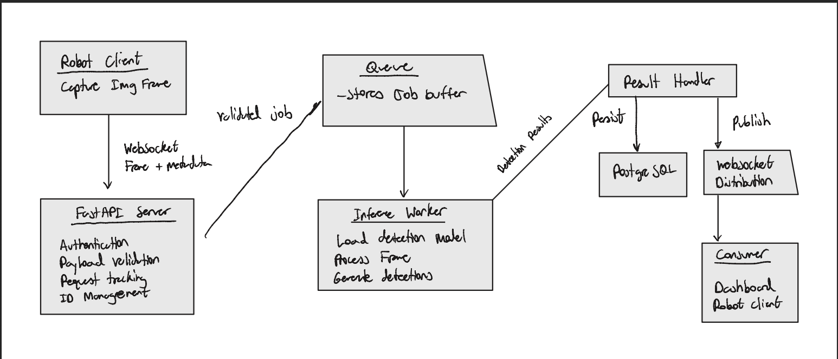

(b) the component boundaries — what is the API layer's responsibility versus the worker's versus the store's;

Component | Responsibilities | What it should not do
Robot client | Capture frames and transmit them using the defined protocol | Depend on backend inference for safety-critical control
FastAPI | Manage connections, authenticate clients, validate payloads, and submit jobs | Execute computationally expensive model inference
Worker queue | Buffer accepted jobs and enforce capacity | Execute inference or permanently store detections
Inference worker | Load models, process frames and generate detections | Manage client connections
Result handler | Correlate results with submitted frames and coordinate delivery and persistence | Perform object detection
PostgreSQL | Persist and retrieve detection records | Execute inference or manage WebSocket connections

(c) the failure modes at each boundary and the intended behavior for each (model not loaded, worker queue full, store unavailable, malformed payload, oversized payload);

Failure | Detection | Proposed backend behavior
Model not loaded | Worker reports that the model is unavailable | Reject new inference jobs until the model becomes ready
Worker queue full | Queue reaches its configured capacity | Reject additional frames and notify the robot client
Store unavailable | Database connection or operation fails | Mark storage as unavailable, record the failure and apply the documented delivery policy
Malformed payload | Request validation fails | Reject the invalid message with an explanation
Oversized payload | Incoming frame exceeds the configured size limit | Reject the frame without submitting it for inference

(d) the initial endpoint inventory for /v1/;

Endpoint | Method | Description
/healthz | GET | Service liveness
/readyz | GET | Service readiness
/v1/frames/stream | WebSocket | Frame submission and inference results
/v1/detections | GET | Retrieve stored detection records
/v1/detections/{detection_id} | GET | Retrieve a specific detection record

(e) non-functional targets — latency budget, throughput target, maximum payload size.

Latency Budget

Stage | Description
Network transmission | Time required to transmit a frame from the robot to the backend
API processing | Time required for FastAPI to validate the incoming frame and submit it to the worker queue
Queue waiting | Time spent waiting for an available inference worker
Model inference | Time required for the worker to process the frame and generate detections
Result delivery | Time required to transmit the detection result to the consumer

The total latency is calculated as:
Total latency = Network transmission + API processing + Queue waiting + Model inference + Result delivery
Because backend inference is not responsible for safety-critical robot navigation, its latency requirements are separate from the robot's onboard control-loop requirements.
The initial numerical latency budget will be established through benchmarking of the selected inference model, expected network conditions, and worker queue behavior.
Measure each processing stage independently to identify performance bottlenecks.
Database persistence latency will be measured separately if detections can be delivered before persistence completes.

Throughput Target

The initial throughput target depends on three primary factors:
- Number of simultaneously connected robots.
- Frame submission rate per robot.
- Processing capacity of the inference worker.
The required aggregate throughput is calculated as:
Required throughput = Number of robots × Submitted frames per second per robot
The initial design uses a bounded worker queue to prevent an excessive accumulation of inference requests.
When the incoming frame rate exceeds the worker's processing capacity, the queue temporarily buffers accepted frames. Once the queue reaches its configured capacity, the API rejects additional frames and sends an appropriate error message to the originating client.
The robot client should respond to overload by reducing its frame submission rate rather than repeatedly submitting rejected frames.
The initial numerical throughput target and maximum supported number of concurrent robots will be established after benchmarking the selected inference model and available hardware.
Throughput testing should measure both the incoming frame rate and the number of frames successfully processed per second.

Maximum Payload Size
The perception service must enforce a maximum incoming frame size to prevent excessive memory consumption, network congestion, and unnecessary processing overhead.
Frames will be transmitted via WebSocket. The initial design proposes JPEG-encoded image frames accompanied by metadata identifying the originating robot, frame ID, timestamp, image dimensions, and payload size.
The maximum payload limit will apply to the compressed image data transmitted by the robot.
The numerical payload limit must be determined using the expected image resolution, JPEG compression characteristics, available server memory, and target network conditions.
The API layer will validate incoming frame sizes before submitting them to the worker queue.
Frames exceeding the configured maximum will be rejected. The client will receive a structured error message containing the corresponding frame ID and an error code indicating that the payload exceeded the permitted size.
The maximum payload size will be implemented as a configurable application setting rather than hardcoded throughout the service.
This allows the limit to be adjusted during performance testing without modifying the API's overall design.
Performance Validation
The maximum payload size will be implemented as a configurable application setting rather than hardcoded throughout the service.
This allows the limit to be adjusted during performance testing without modifying the API's overall design.

Proposed Engineering Targets
p95 latency target of 1 second - It establishes a measurable target for backend perception while keeping safety-critical decisions onboard. It is an initial requirement, not a guarantee that one-second latency is sufficient for every possible use case.
Throughput target of 2 frames per second - It supports an initial workload of two robots transmitting one frame per second. Under the assumed 300 ms average inference time, the worker has theoretical spare capacity.
Maximum payload size of 2 MB per frame - It establishes a practical initial upper limit for compressed 720p JPEG frames, helping control bandwidth and memory usage without unnecessarily restricting normal images.

